Christy Lou Clayton, M.D.

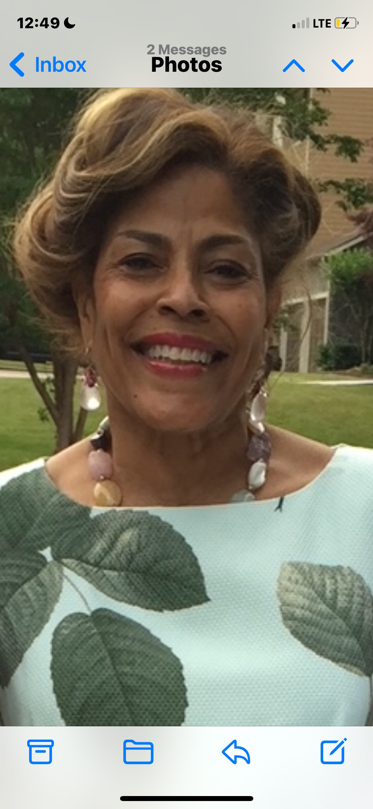
Ms. Christy Lou Clayton, M.D., age 63, entered eternal rest on Tuesday, August 9, 2022 at Duke Hospice-Hock Family Pavilion in Durham, North Carolina. She was a native of Roxboro, North Carolina where she was a member of St. Mark’s Episcopal Church.
Christy’s life was joyously full of family, friends and fun. As a physician (Ob/Gyn), she brought babies into the world and cared for women’s health needs. Her days and nights were often long, but she found time to enjoy the finer things of life – travel, good food and gorgeous clothes.

Christy inherited her good taste and strong work ethic from her parents. Her mother, Christine Clayton Pope, is still going strong at almost 96 years old. Sadly, her father - Dr. Dewey Monroe Clayton III - also a physician, passed in 1977. However, he left Christy with the desire to care for the medical needs of others.
Upon her 1980 graduation from Spelman College in Atlanta, Georgia, Christy attended East Carolina University’s Brody School of Medicine in Greenville, North Carolina. Upon receiving her medical degree, Christy spent several years developing and providing women’s health care. In 1994, she established her own private practice, “Cary Women’s Center” in Cary, North Carolina.
Christy was never idle. She was involved in numerous boards and foundations, including The Girlfriends, Inc. and the National Smart Set, Durham Chapter where she served as a past president. She was on the Board of Trustees at Bennett College in Greensboro, North Carolina.
Christy loved the water. She could spend hours at the pool. Any beach was a source of solace – from the coast of the Carolinas to California, Hawaii, Mexico and other beaches abroad.
We will all miss Christy’s spirit and her shining light. However, we know that we shall meet again in the great beyond.
Christy is survived by her mother Christine Clayton Pope; sisters Dawn and Cassandra; brother Dewey; niece Kristen; god son Clayton Powell-Lee; and numerous loving aunts, uncles, cousins and friends.

