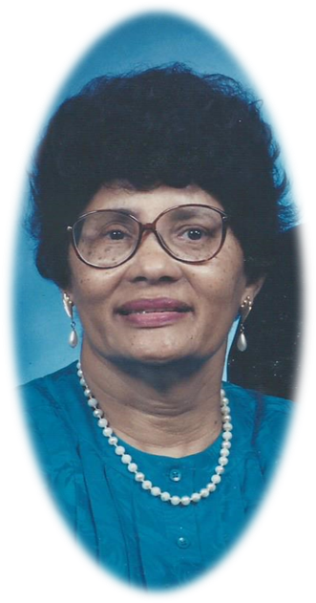
Mary Lou Goods Coley peacefully transitioned from her earthly home on March 24, 2016 after a 25-year battle with multiple sclerosis.

Mary was the daughter of the late Earvin and Claudia Paylor Goods. She was preceded in death by four brothers – James Goods , William Goods, Jimmy Goods and Irvin “Ike” Goods.

In addition to her husband of 60 years, Ronnie Coley, Mary is also survived by: a sister, Ossie G. Clay (husband Jasper) of Columbia, MD and a brother Earl Goods of Bronx, New York. Three nieces, Ernestine Goods and Ann G Clay (husband Rev Benjamin) of Roxboro and Rev. Regina Clay of Columbia, MD; four nephews Reginald Clay of Columbia, MD; Jermaine Goods of Baltimore, MD; Mark Goods of Durham, NC and Ronnie Robles, of New York (whom she reared). Also left to cherish her memory is her devoted and loyal childhood friend Glory Coley in addition to great and great-great nieces, nephews, cousins, and other relatives and friends

Mrs. Mary Lou Goods Coley

Visitation

Sunday, March 27, 2015
2 PM to 7 PM
Family Present 6 PM to 7 PM
Hester, Whitted & Daye Funeral Service
603 South Main Street
Roxboro, NC 27573
Phone: (336) 599-0104

Funeral Service

Monday, March 28, 2015
2 PM
Union Grove Baptist Church
3081 Union Grove Church Road
Hurdle Mills, North Carolina
Phone: (336) 599-3081

Rev Rufus L. Johnson, Officiating

Burial

Union Grove Baptist Church Cemetery
Hurdle Mills, North Carolina

